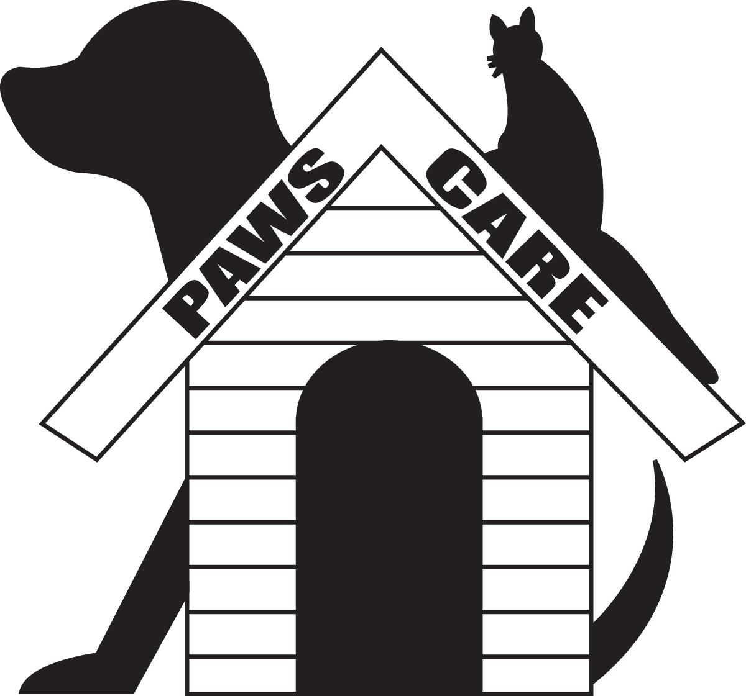
Paws Care “Andy & Debbie Schum” Scholarship Award

Award Amount: $500.00 U.S. Dollars per scholarship
Deadline for Submission: April 15 of each Scholarship Year
Description: The Paws Care/Schum Scholarship Award is available to any individual in Montgomery County, IL who plans on attending a college or technical school in the U.S.
2 scholarships will be awarded to residents in Montgomery County in 2020.

Qualifications:
You must do the following to qualify:
- Volunteer a minimum of 10 hours with Paws Care and complete the volunteer form with signatures. Please fill out the volunteer form on this site or send an email to pawsvolunteerchair@gmail.com to receive email updates on volunteer opportunities.
- Create and complete one fundraiser for Paws Care of Montgomery County. Contact Paws Care for fundraiser approval*.
- Write an essay about the above two experiences. The essay should be between 200 and 400 words.
- Your check will be mailed to you upon proof of the successful completion of your first semester. Please send a copy of your grade report to the address below.

Application:
All submissions must include the Paws Care volunteer form with signatures and the essay. Submissions must be sent through regular mail or placed in the Paws Care mailbox. Submissions via email will not be accepted.

Submissions must be mailed to:
Paws Care/Schum Scholarship
P.O. Box 25
Hillsboro, IL 62049

*Prior to implementation of your Paws Care fundraiser, please contact Paws Care at pawsvolunteerchair@gmail.com for approval.

Paws Care Volunteer Form

Date | Number of Hours Volunteered | Paws Care Board Member Signature

Many volunteer options are available.
Please check with our volunteer chair at pawsvolunteerchair@gmail.com

